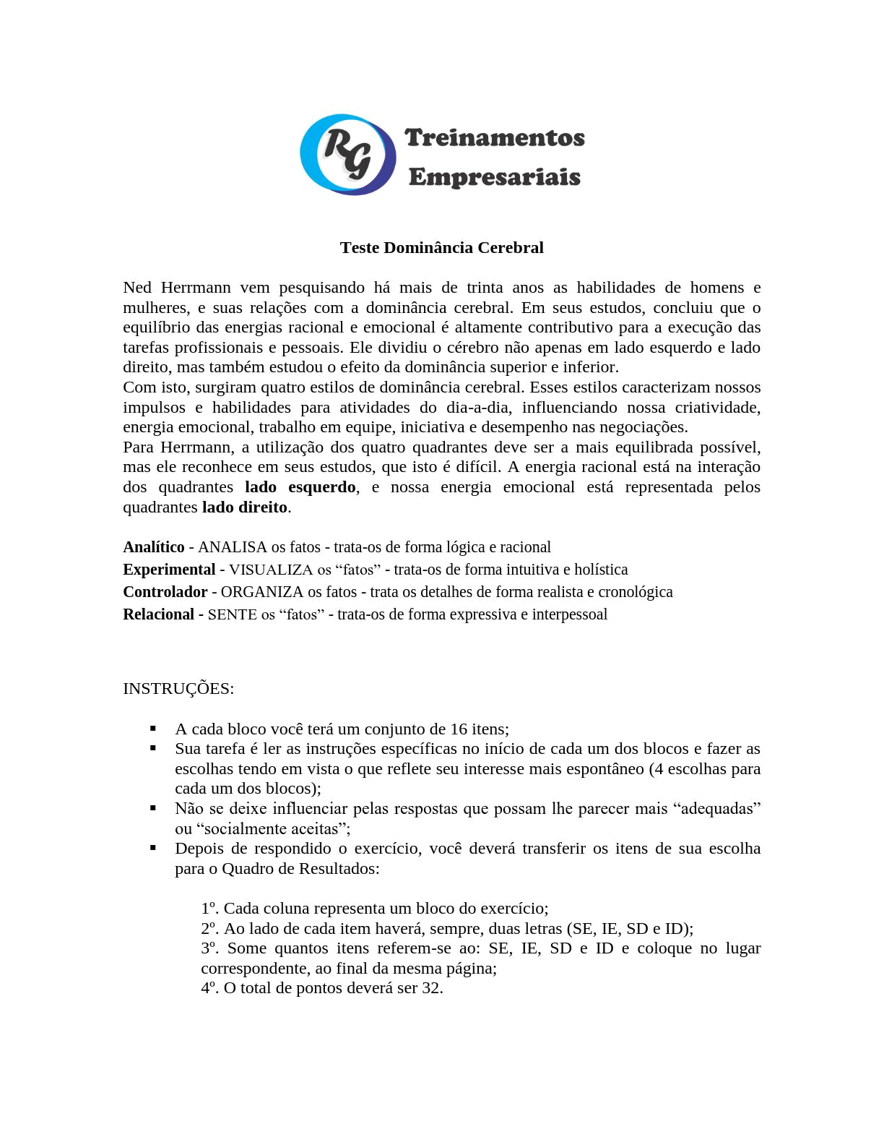
21/05/2019 DocPlayer

https://docplayer.com.br/34374028-Teste-dominancia-cerebral.html 1/7

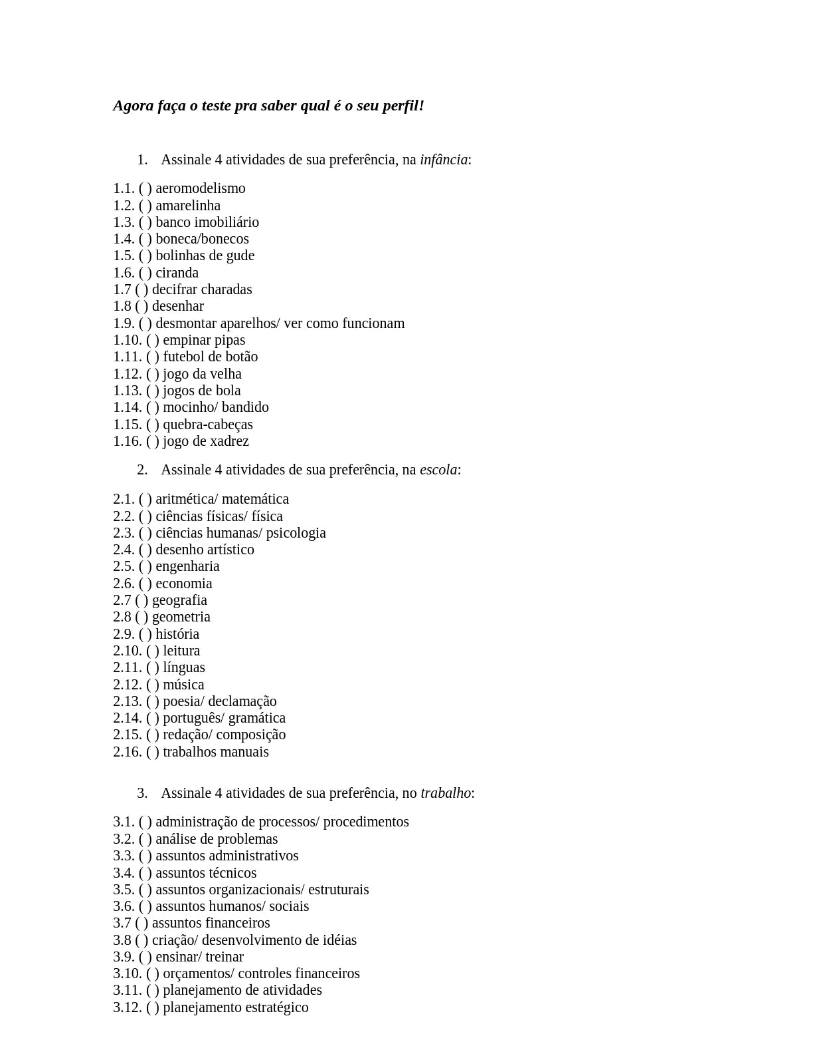
21/05/2019 DocPlayer

https://docplayer.com.br/34374028-Teste-dominancia-cerebral.html 2/7

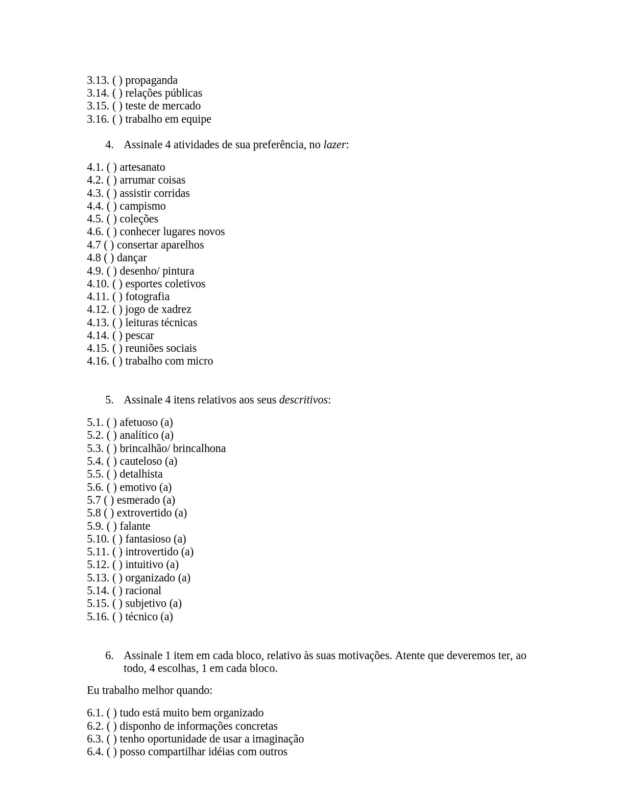
21/05/2019 DocPlayer

https://docplayer.com.br/34374028-Teste-dominancia-cerebral.html 3/7

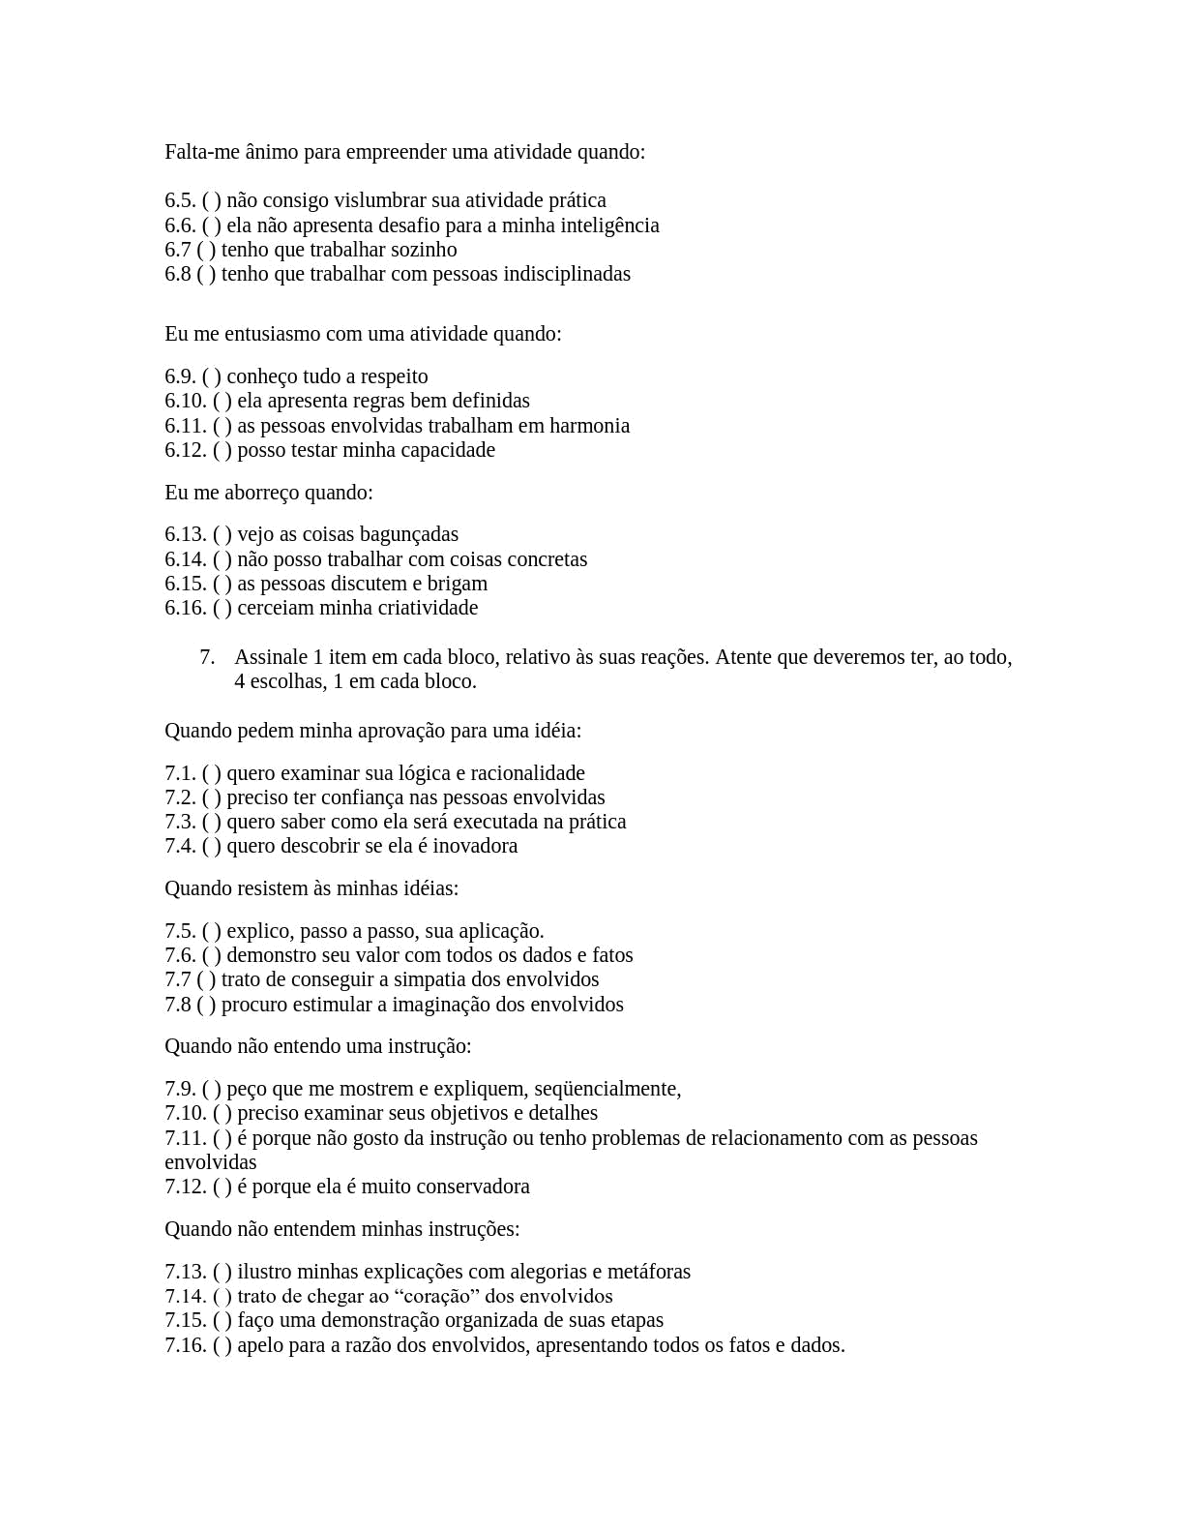
21/05/2019 DocPlayer

https://docplayer.com.br/34374028-Teste-dominancia-cerebral.html 4/7

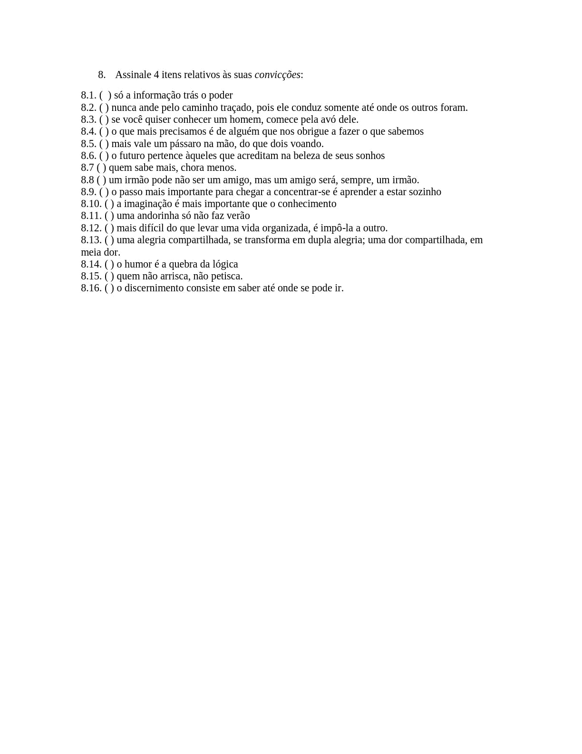
21/05/2019 DocPlayer

1.3 1.8 1.15 1.13 2.1 2.2 2.32.4 3.2 3.4 3.8 3.9 4.4 4.5 4.12 4.14 5.3 5.5 5.1 5.16 6.2 6.7 6.10 6.14 7.1 7.6 7.9 7.16 8.5 8.9 8.10 8.13

https://docplayer.com.br/34374028-Teste-dominancia-cerebral.html 5/7

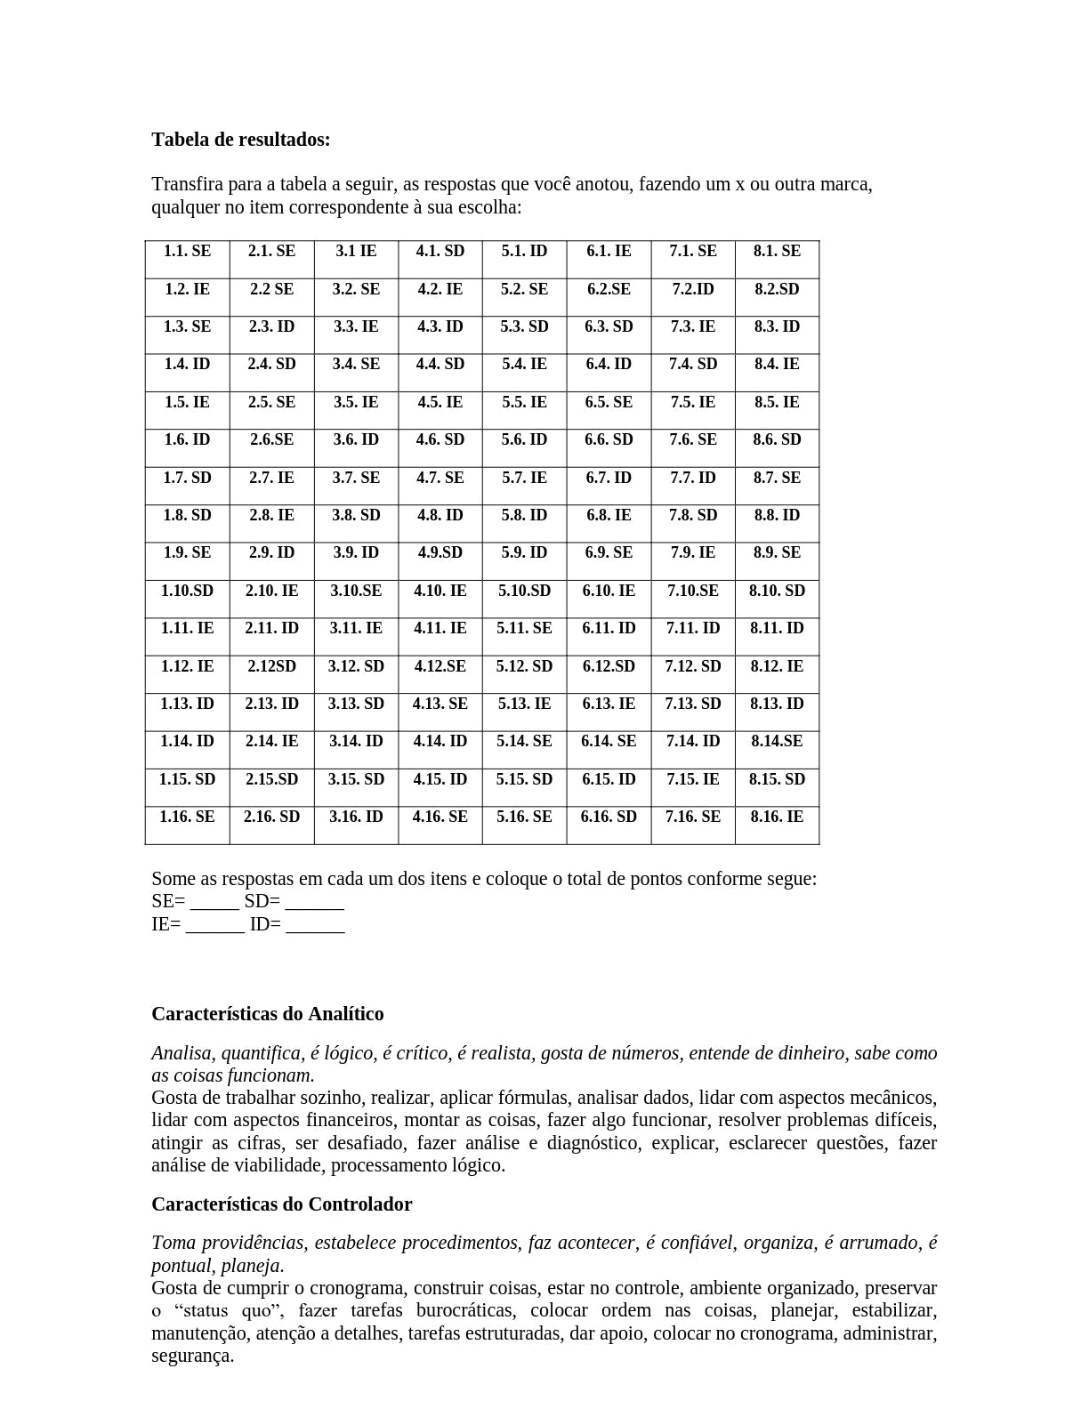
21/05/2019 DocPlayer

SE = 13
SD = 7
IE = 5
ID = 7

SE SD SD ID SE SE ID SD SE SE SD ID SD IE SE ID SD IE ID SE SE ID IE SE SE SE IE SE IE SE SD ID

https://docplayer.com.br/34374028-Teste-dominancia-cerebral.html 6/7

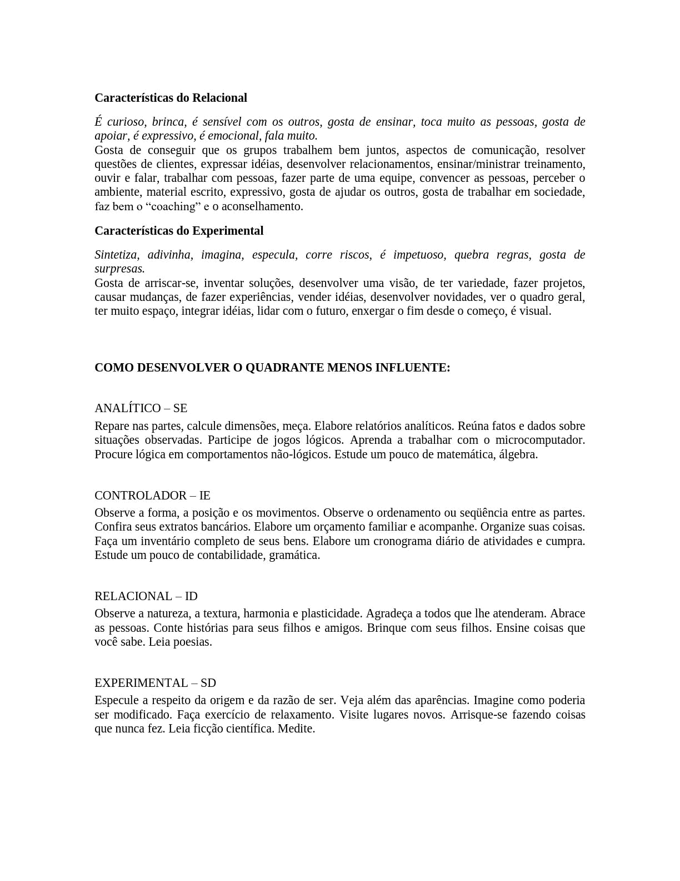
21/05/2019 DocPlayer

https://docplayer.com.br/34374028-Teste-dominancia-cerebral.html 7/7

